Recommendations on 5G system implementation and design trade-offs

Module: 5G Data Processing(EE45GS)

Student: Akhmadjon Rajabov

Student ID: 190200705

Professor: Mariia Sorokina, PhD

Academic year: 2019-2020

Contents

Introduction………………………………………………………………………..3

Requirements of 5G……………………………………………………………….3

Challenges of 5G…………………………………………………………………..3

Key Components of 5G……………………………………………………………3

Waveform Standards and Requirements…………………………………………..4

OFDM……………………………………………………………………………..4

FBMC……………………………………………………………………………..6

Difference between OFDM and FBMC…………………………………………..6

Performance Metrics……………………………………………………………...8

Conclusion……………………………………………………………………….11

References………………………………………………………………………..12

Application……………………………………………………………………….13

Introduction

In recent years, the development of demand for the use of the Internet and the demand of users has attracted great attention to mobile access networks. 4G, Long Term Evolution currently is not able to meet the network requirements, therefore, the development of new transmission methods with several carriers is the most attractive for the development of a 5G successor. Orthogonal frequency division multiplexing (OFDM) and multi-carrier filter modulation (FBMC) are the dominant waveform candidates for fifth generation wireless communications. The cyclic prefix OFDM method (CP-OFDM), which uses the orthogonal set of subcarriers, is undoubtedly the most common multi-carrier system, but the severe requirement of this method for tight timing and synchronization requirement becomes a problem to achieve its goals [1].

**Requirements of 5G**

High average data transfer rate increased from 10 Kbit / s to 1 Gbit / s, connection quality, very low latency up to 1 ms for ultra-reliable communication with low delay to ensure successful real-time interactivity, as well as an increase in devices connected to the Internet, optimization and increase the energy efficiency of connected devices, all these data requirements are currently being pushed to 5G.

**Challenges of 5G**

To solve the requirements at the moment, scientists faced many problems such as making spectrum distribution more flexible, how to expand addressable spectrum into higher frequency bands, how to solve the difficulty in managing providing communications between a large number of devices, traffic, inter-cell interference.

**Key Components of 5G**

5G core network (CN), 5G new radio (NR) and 5G devices, user equipment (UE) are the end-to-end 5G network architecture. 5G core network (CN), 5G access network (AN) and 5G devices, user equipment (UE) can be attributed to the most key levels of architecture. Also, the user plane (UP), control plane (CP), access network (AN), core network (CN) and public land mobile network (PLMN) are key components of the network.

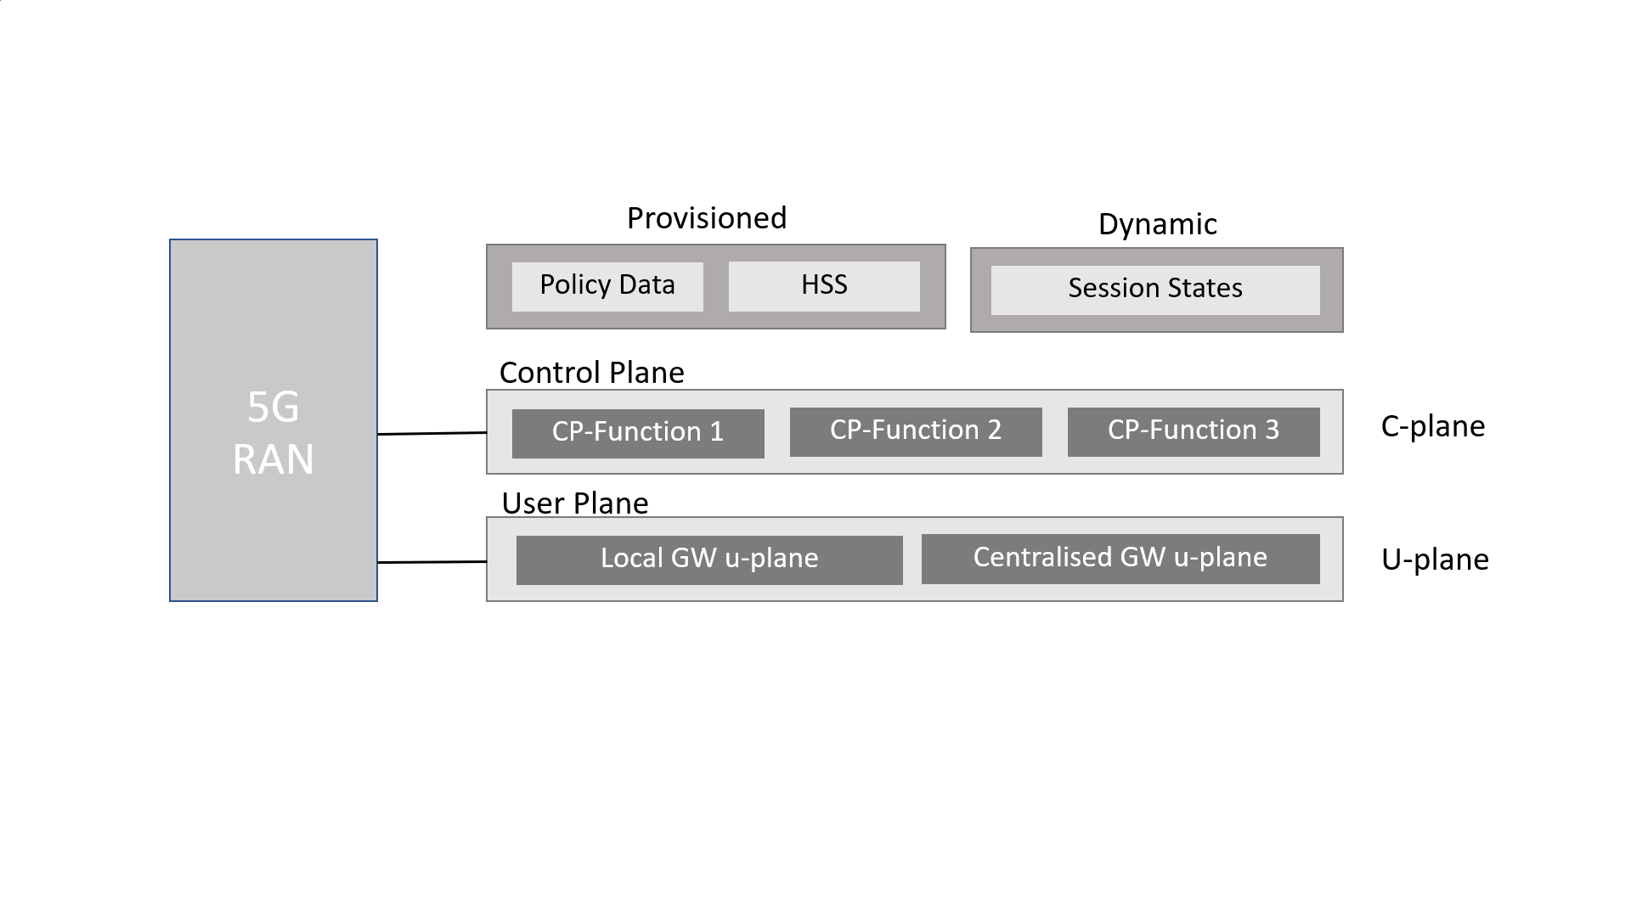

Figure 1 5G system Diagram

To ensure independent scalability and flexible deployment, the user plane (UP) and control plane (CP) are separate from each other. The network architecture is defined using a converged core network (CN) with a common access network (AN) - core network (CN) interface. Deploying a user plane (UP) close to an access network (AN) provides a low latency service and access to a local data network.

**Waveform Standards and Requirements**

The requirements for the waveform for 5G at the physical level are the ability to cut low latency, process the signal at high speed data transmission with a wide bandwidth, short processing time for data packets, and the ability to quickly switch from the uplink and downlink and vice versa for systems with time divisions. Also, reduce turn-on times to improve the energy efficiency of low-data devices.

**OFDM**

An orthogonal frequency division multiplexing (OFDM) scheme is used as a digital carrier modulation technique. A method of encoding digital data at several non-continuous frequencies. In a system where multiple OFDM carriers, the frequency spectrum of the subcarriers overlaps with the smallest frequency spacing, and orthogonality is achieved among the various subcarriers.

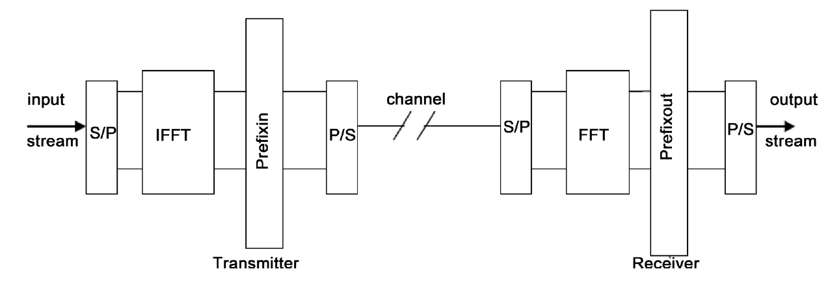

Figure 2 Block diagram of Orthogonal Frequency Division Multiplexing

In Figure 2, the input stream is subdivided into parallel data streams by means of the serial to parallel (S/P) converter, which is then passed into an inverse fast Fourier transformation (IFFT) block to produce time sequence of the streams. Consequently, by totaling a cyclic prefix (CP), the OFDM symbol time sequences are extended. The CP is a copy of the latter portion of the symbol that is added at the start of the sequence and should be greater than the network deferral spread in order to diminish the inter symbol interference (ISI) produced by the influx of various OFDM symbols with distinct delay. The resultant digital signal is transformed into analog form and transmitted over the channel [5].

At the receiver end, the signal is reconstructed into digital form and the far Fourier transform (FFT) is achieved in the received streams after eradicating the CP [5]. Finally, the parallel streams are collected into a single stream as the original transmitted one. OFDM is not the most ideal circuit and it also has its drawbacks, such as reduced spectral efficiency due to the used CP, high spectral leakage due to a rectangular window, interference among an unsynchronized signal in adjacent bands. Furthermore, the CP employed is chastely redundant in terms of information and significantly diminishes the bandwidth efficiency. The disadvantages of OFDM technique were overcome by a multicarrier communication system called FBMC first proposed by Saltzberg [3] that delivers an improved spectral shaping of subcarriers than OFDM systems. This is then achieved by the careful designing of the prototype filter, which abridges equalization in the lack of CP and also promises an additional effectual spectral utilization by diminishing interference across subcarriers. By engaging Offset Quadrature Amplitude Modulation (OQAM), the full capacity of the transmission bandwidth can be attained in FBMC systems.

**FBMC**

The FBMC technique overcomes the limitations of OFDM by adding generalized pulse shaping filters which deliver a well-localized sub-channel in both time and frequency domain. Consequently, FBMC systems have more spectral containment signals and offer more effective use of radio resources where no CP is required. In Figure 3 it can be seen that the filter banks on the transmitter side and the receiver side consist of an array of N filters that process N input signals to give N outputs. If the inputs of these N filters are associated together, the system is analogous manner can be measured as an analyzer to the input signal based on each filter characteristics. In Figure 3 the filter bank used at the transmitter side is called a synthesis filter bank and the filter bank used in the receiver side is called analysis filter bank.

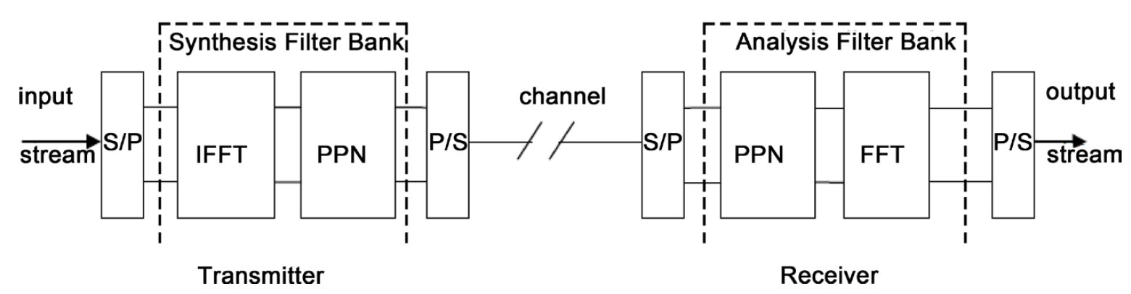

Figure 3. Block diagram of Filter Bank Multi Carrier (FBMC)

As depicted in Figure 3 the input signal is first converted from serial to parallel form and then passed through synthesis filter bank and then it is converted back to serial form after coming out of synthesis bank. After this, it can be seen in Figure 3 that on the receiver side after the signal passes through the channel it is converted to parallel form by serial to parallel converter and passed through analysis filter bank. Finally, when the output signal is obtained it is again converted to serial form by parallel to serial converter [7].

**Differences between OFDM and FBMC**

FBMC is an evolved version of OFDM. The modulators of the OFDM technique and FBMC technique are illustrated in Figure 2 [5]. The main difference is the replacement of the OFDM with a multicarrier system based on filter banks, where the IFFT plus *CPin* is substituted by the synthesis filter bank (SFB) whereas FFT plus *CPout* is substituted by the analysis filter bank (AFB). The main differences between OFDM and FBMC techniques have been summarized in Table 1 on the properties—cyclic prefix, sidelobes, synchronization, Doppler effect, MIMO systems, Spectrum sensing, and computational complexity. The basic principles of OFDM and FBMC are explicated below.

Table 1. Major differences between OFDM and FBMC

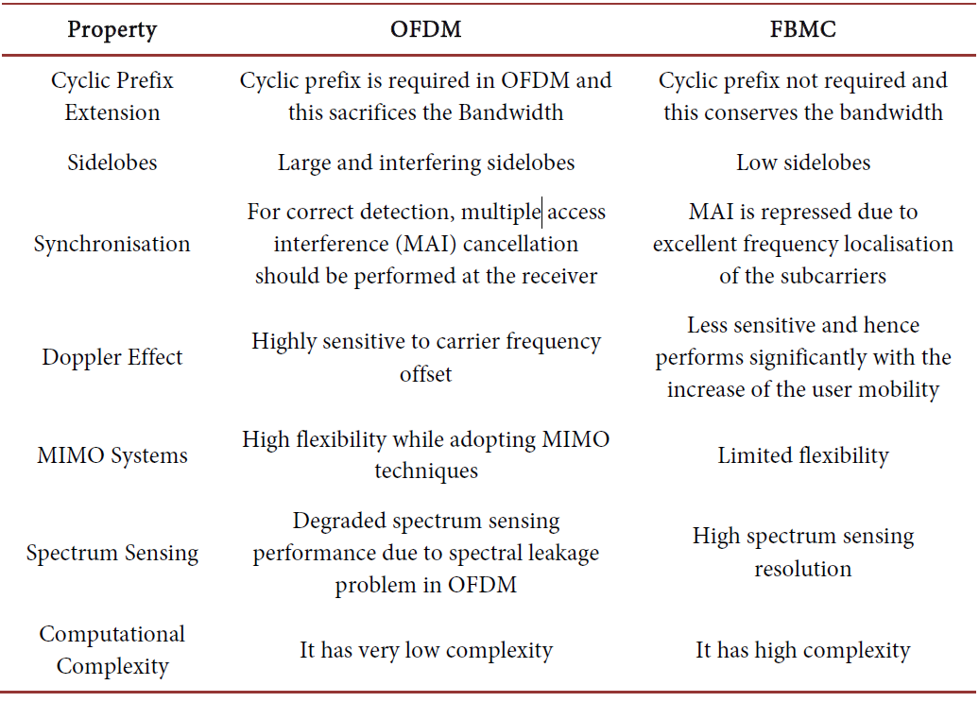

**Performance Matrices**

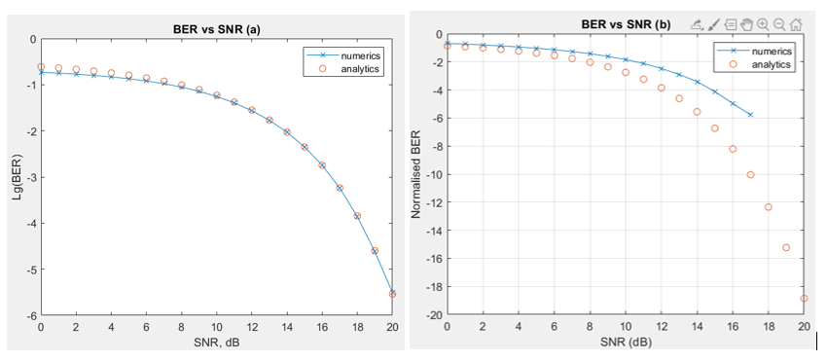

Figure 4 (a) OFDM BER vs SNR, (b) FBMC BER vs SNR

Figure 4 implies the performance of BER versus SNR for OFDM (a), FBMC (b), respectively. As shown in the figure, BER is of great importance at low SNR and gradually decreases with increasing SNR. With a high SNR, the BER may be zero, but this is almost impossible because using high SNR power reduces system performance. From this it follows that transmission quality is achieved by efficient power control.

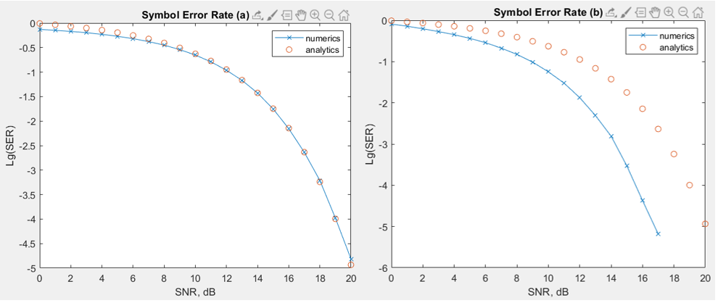

Figure 5 (a) OFDM SER vs SNR, (b) FBMC SER vs SNR

Figure 5 implies the performance of SER versus SNR for OFDM (a), FBMC (b), respectively. As shown in the figure, SER is of great importance at low SNR and gradually decreases with increasing SNR. The principle of operation of SER is similar to that of BER.

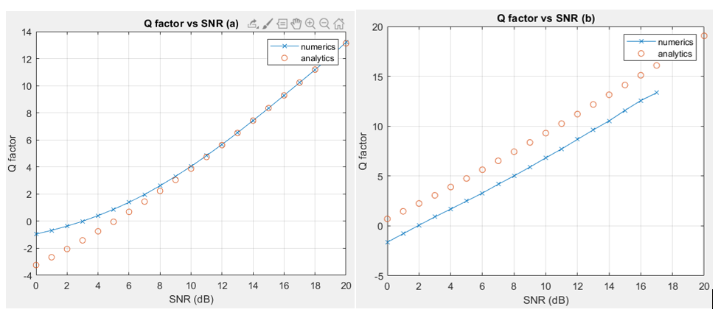

Figure 6 (a) OFDM Q-factor vs SNR, (b) FBMC Q-factor vs SNR

Figure 6 illustrates the relationship between Q-factor and SNR for OFDM and FBMC. The Q-factor is inversely proportional to the attenuation rate of natural oscillations in the system. In other words, the higher the Q-factor of the system, the less energy loss. As we can see from the graph in both cases, the quality factor increases on an equal footing with SNR.

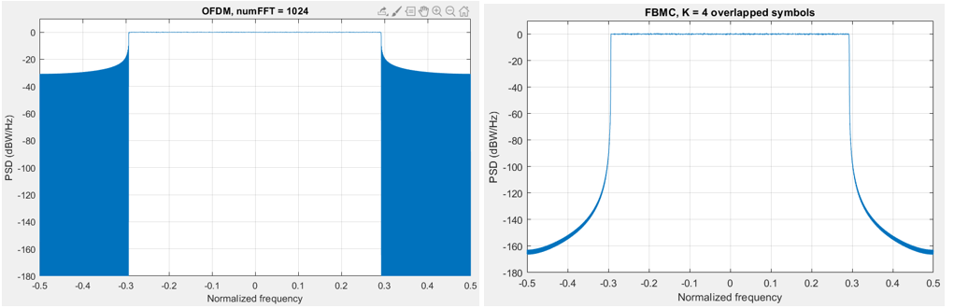

Figure 7 Power spectral density of OFDM and FBMC.

To ensure low out-of-band leakage, the FBMC uses the power spectral density of the transmitted signal. Figure 7 compares the spectral density plots for OFDM and FBMC schemes. As can be seen from the figure, the FBMC has smaller side lobes. This makes it possible to use the selected spectrum an additional time to increase the efficiency of spectrum use. As for OFDM, it has higher side lobes and out-of-band leakage. Thus, the FBMC scheme is more advantageous than OFDM, providing higher spectral efficiency.

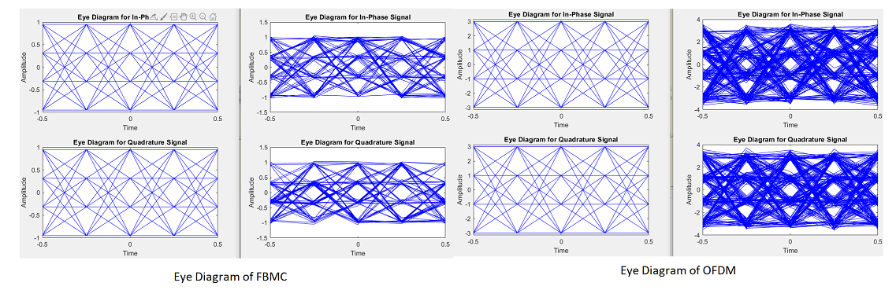

Figure 8 Eye Diagram of FBMC and OFDM

The Eye Diagram shows us how inter-symbol interference affects a signal in an FBMС and OFDM scheme. As we can see in OFDM, the eye is more closed thereby showing us that inter-symbol interference is higher than that of FBMС.

**Conclusion**

In this work, a comparison of the performance of OFDM and FBMC was made as the most potential 5G applicants were conducted and modeled using MATLAB in terms of power spectral density, Q-factor, Bit Error Rate, Symbol Error Rate and Eye Diagram of OFDM and FBMC curves. To summarize, recommendations that the FBMC method is the most promising candidate for 5G wireless communication. It can also be said that FBMC derives from OFDM. More precisely, the FBMC takes all the advantages of OFDM and tries to remove OFDM flaws, while the FBMC has its own new flaws, such as short bursts and MIMO.

**References**

[1] Weiss, T.A. and Jondral, F.K. (2004) Spectrum Pooling: An Innovative Strategy for the Enhancement of Spectrum Efficiency. IEEE Communications Magazine, 42, S8-S14. https://doi.org/10.1109/MCOM.2004.1273768

[2] Schafer, D.J. (2001) Wide Area Adaptive Spectrum Applications. Proceedings of IEEE MILCOM, 1, 1-5. <https://doi.org/10.1109/MILCOM.2001.985752>

[3] Saltzberg, B. (1967) Performance of an Efficient Parallel Data Transmission System. IEEE Transactions on Communication Technology, 15, 805-811. <https://doi.org/10.1109/TCOM.1967.1089674>

[4] Farhang Boroujeny, B. (2008) A Square Root Nyquist (M) Filter Design for Digital Communication Systems. IEEE Transactions on Signal Processing, 56, 2127-2132. <https://doi.org/10.1109/TSP.2007.912892>

[5] Tensubam, B.D., Chanu, N.L. and Singh, S. (2014) Comparative Analysis of FBMC and OFDM Multicarrier Techniques for Wireless Communication Networks. International Journal of Computer Applications, 100, 27-31. <https://doi.org/10.5120/17636-8382>

[6] Schaich, F. (2010) Filterbank Based Multicarrier Transmission (FBMC)-Evolving OFDM. Bell Labs Alcatel-Lucent.

[7] Hidalgo Stitz, T. (2010) Filterbank Techniques for the Physical Layer in Wireless Communications. Ph.D. Theses, Tampere University of Technology Publications, Tampere, 919 p.

[8] Vaidyanathan, P.P. (1993) Multirate Systems and Filterbanks. Prentice Hall, Upper Saddle River.

[9] FP7-ICT Future Networks PHYDYAS—PHYsical Layer for DYnamic AccesS and Cognitive Radio Project (ICT-211887). http://www.ict-phydyas.org/delivrables/PHYDYAS-D5-1.pdf/view

Application

OFDM code for MATLAB

%% OFDM

clear all;

close all;

clc

M = 16; % 16-QAM constellation

N = 2^20; % number of symbols

no_of_ifft_points = 2^6; % points for the FFT/IFFT

no_of_fft_points = 2^6;

block_size = no_of_fft_points; % number of symbols per ofdm channel

cp_len = ceil(0.1*block_size); % length of cyclic prefix

coordinates = [-3 -1 1 3];

numSamplePerSymbol = 2;

tic

%% Transmitter side

% Signal modulation

input = randsrc(1,N,coordinates) + 1i*randsrc(1,N,coordinates);

% First step: obtain the number of OFDM channels (i.e. columns) that will exist after reshaping

num_ch = length(input)/block_size;

data_matrix = reshape(input, block_size, num_ch);

x = reshape(data_matrix, 1, (block_size * num_ch)); %input data in series form for eyediagram

% Second: Create empty matix to put the IFFT'd data

cp_start = block_size-cp_len;

cp_end = block_size;

% Third: Operate columnwise & do CP

for i=1:num_ch

ifft_data_matrix(:,i) = ifft((data_matrix(:,i)),no_of_ifft_points);

% Compute and append Cyclic Prefix

for j=1:cp_len

actual_cp(j,i) = ifft_data_matrix(j+cp_start,i);

end

% Append the CP to the existing block to create the actual OFDM block

ifft_data(:,i) = vertcat(actual_cp(:,i),ifft_data_matrix(:,i));

end

% Convert parallel to serial for transmission

[rows_ifft_data cols_ifft_data] = size(ifft_data);

len_ofdm_data = rows_ifft_data * cols_ifft_data;

% Actual OFDM signal to be transmitted

ofdm_signal = reshape(ifft_data, 1, len_ofdm_data);

%% Channel

snr_dB = [0:20]; % here we use a loop to vary snr

errors = zeros(size(snr_dB));

for ii = 1:length(snr_dB)

s = 1/sqrt(mean(abs(ofdm_signal).^2)); % 16-QAM normalization

n = 1/sqrt(2)*(randn(1,len_ofdm_data) + 1i*randn(1,len_ofdm_data)); % normalized guassian noise

% Pass the ofdm signal through the channel

recvd_signal = s * ofdm_signal + 10^(-snr_dB(ii)/20) * n; % linear AWGN

%% Receiver side

% Convert Data back to "parallel" form to perform FFT

recvd_signal_matrix = reshape(recvd_signal,rows_ifft_data, cols_ifft_data);

% Remove CP

recvd_signal_matrix(1:cp_len,:)=[];

% Perform FFT

for i=1:cols_ifft_data

fft_data_matrix(:,i) = fft(recvd_signal_matrix(:,i),no_of_fft_points);

end

% Convert parallel to serial

y = reshape(fft_data_matrix, 1,(block_size*num_ch));

y = y./s;

% Hard decision

y_re = real(y); % real part

y_im = imag(y); % imaginary part

out_re = y_re; out_im = y_im;

out_re(y_re < -2) = -3;

out_re(y_re > 2) = 3;

out_re(y_re > -2 & y_re <= 0) = -1;

out_re(y_re > 0 & y_re <= 2) = 1;

out_im(y_im < -2) = -3;

out_im(y_im > 2) = 3;

out_im(y_im > -2 & y_im <= 0) = -1;

out_im(y_im > 0 & y_im <= 2) = 1;

out = out_re + 1i * out_im;

errors(ii) = length(find(input - out)); % calculate errors

end

%% Graph

scatterplot(input); title('Modulated data');

scatterplot(y); title('Received symbols before mapping');

scatterplot(out); title('Received symbols');

%to plot OFDM signal

plot(real(ofdm_signal)); xlabel('Time'); ylabel('Amplitude');

title('OFDM Signal');grid on;

%SER

Ser = errors / N;

formula_Ser = 3/2 * erfc(sqrt(0.1 * (10.^(snr_dB/10)))); %theoritical

figure

plot(snr_dB, log10(Ser),'-x'); hold on; %numerics

plot(snr_dB, log10(formula_Ser),'o'); %analytics

legend('numerics','analytics');

xlabel('SNR, dB');

ylabel('Lg(SER)');

title('Symbol Error Rate (a)');

%BER

Ber = Ser / 4 ; % a number of bits per symbol 16 QAM

formula_Ber = (1/4.0) * 3/2 * erfc(sqrt(0.1 * (10.^(snr_dB/10)))); %theoritical

figure

plot(snr_dB, log10(Ber),'-x'); hold on; %numerics

plot(snr_dB, log10(formula_Ber),'o'); %analytics

legend('numerics','analytics');

xlabel('SNR, dB');

ylabel('Lg(BER)');

title('BER vs SNR (a)');

%Eye Diagram

eyediagram(x(1:1000), numSamplePerSymbol^2); %transmitter

eyediagram(y(1:1000), numSamplePerSymbol^2); %receiver

%Q-factor

Q = 20 * log10(sqrt(2) * (erfcinv(2 * (Ber))));

formula_Q = 20 * log10(sqrt(2) * (erfcinv(2 * (formula_Ber))));

figure

plot(snr_dB, Q,'-x'); hold on; %numerics

plot(snr_dB, formula_Q,'o'); %analytics

title('Q factor vs SNR (a)');

ylabel('Q factor');

xlabel('SNR (dB)');

grid on

legend('numerics','analytics');

%Bandwidth efficiency

BW = no_of_fft_points/(no_of_fft_points + cp_len);

fprintf('Bandwidth efficiency is %.2f bit/s/Hz\n',BW)

toc

%%

FBMC code for MATLAB

clear all

clc

close

s = rng(211);

numFFT = 1024; % Number of FFT points

numGuards = 212; % Guard bands on both sides

K = 4; % Overlapping symbols, one of 2, 3, or 4

numSymbols = 2^10; % Simulation length in symbols

bitsPerSubCarrier = 4; % 2: 4QAM, 4: 16QAM, 6: 64QAM, 8: 256QAM

snrdB = [0:20]; % SNR in dB

num_samples_each_trace = 4; %number of samples for each trace for eye

%diagram

tic

% Prototype filter

switch K

case 2

HkOneSided = sqrt(2)/2;

case 3

HkOneSided = [0.911438 0.411438];

case 4

HkOneSided = [0.971960 sqrt(2)/2 0.235147];

otherwise

return

end

% Build symmetric filter

Hk = [fliplr(HkOneSided) 1 HkOneSided];

% Transmit-end processing

% Initialize arrays

L = numFFT-2*numGuards; % Number of complex symbols per OFDM symbol

KF = K*numFFT;

KL = K*L;

dataSubCar = zeros(L, 1);

dataSubCarUp = zeros(KL, 1);

sumFBMCSpec = zeros(KF*2, 1);

sumOFDMSpec = zeros(numFFT*2, 1);

numBits = bitsPerSubCarrier*L/2; % account for oversampling by 2

inpData = zeros(numBits, numSymbols);

rxBits = zeros(numBits, numSymbols);

txSigAll = complex(zeros(KF, numSymbols));

symBuf = complex(zeros(2*KF, 1));

% Loop over symbols

for symIdx = 1:numSymbols

% Generate mapped symbol data

inpData(:, symIdx) = randi([0 1], numBits, 1);

modData = qammod(inpData(:, symIdx), 2^bitsPerSubCarrier, ...

'InputType', 'Bit', 'UnitAveragePower', true);

% OQAM Modulator: alternate real and imaginary parts

%The real and imaginary parts of a complex data symbol

%are not transmitted simultaneously, as the imaginary part is delayed

%by half the symbol duration.

if rem(symIdx,2)==1 % Odd symbols

dataSubCar(1:2:L) = real(modData);

dataSubCar(2:2:L) = 1i*imag(modData);

else % Even symbols

dataSubCar(1:2:L) = 1i*imag(modData);

dataSubCar(2:2:L) = real(modData);

end

% Upsample by K, pad with guards, and filter with the prototype filter

dataSubCarUp(1:K:end) = dataSubCar;

dataBitsUpPad = [zeros(numGuards*K,1); dataSubCarUp; zeros(numGuards*K,1)];

X1 = filter(Hk, 1, dataBitsUpPad);

% Remove 1/2 filter length delay

X = [X1(K:end); zeros(K-1,1)];

% Compute IFFT of length KF for the transmitted symbol

txSymb = fftshift(ifft(X));

% Transmitted signal is a sum of the delayed real, imag symbols

symBuf = [symBuf(numFFT/2+1:end); complex(zeros(numFFT/2,1))];

symBuf(KF+(1:KF)) = symBuf(KF+(1:KF)) + txSymb;

% Compute power spectral density (PSD)

currSym = complex(symBuf(1:KF));

[specFBMC, fFBMC] = periodogram(currSym, hann(KF, 'periodic'), KF*2, 1);

sumFBMCSpec = sumFBMCSpec + specFBMC;

% Store transmitted signals for all symbols

txSigAll(:,symIdx) = currSym;

end

%Scatterplot of modulated data (constellation diagram)

scatterplot(modData);title('modulated data')

% Plot power spectral density

sumFBMCSpec = sumFBMCSpec/mean(sumFBMCSpec(1+K+2*numGuards*K:end-2*numGuards*K-K));

plot(fFBMC-0.5,10*log10(sumFBMCSpec));

grid on

axis([-0.5 0.5 -180 10]);

xlabel('Normalized frequency');

ylabel('PSD (dBW/Hz)')

title(['FBMC, K = ' num2str(K) ' overlapped symbols'])

set(gcf, 'Position', figposition([15 50 30 30]));

% Process symbol-wise

BERR=zeros(size(snrdB));

for ii = 1:length(snrdB)

BER = comm.ErrorRate;

for symIdx = 1:numSymbols

rxSig = txSigAll(:, symIdx);

% Add WGN

rxNsig = awgn(rxSig, ii, 'measured');

% Perform FFT

rxf = fft(fftshift(rxNsig));

% Matched filtering with prototype filter

rxfmf = filter(Hk, 1, rxf);

% Remove K-1 delay elements

rxfmf = [rxfmf(K:end); zeros(K-1,1)];

% Remove guards

rxfmfg = rxfmf(numGuards*K+1:end-numGuards*K);

% OQAM post-processing

% Downsample by 2K, extract real and imaginary parts

if rem(symIdx, 2)

% Imaginary part is K samples after real one

r1 = real(rxfmfg(1:2*K:end));

r2 = imag(rxfmfg(K+1:2*K:end));

rcomb = complex(r1, r2);

else

% Real part is K samples after imaginary one

r1 = imag(rxfmfg(1:2*K:end));

r2 = real(rxfmfg(K+1:2*K:end));

rcomb = complex(r2, r1);

end

% Normalize by the upsampling factor

rcomb = (1/K)*rcomb;

% De-mapper: Perform hard decision

rxBits(:, symIdx) = qamdemod(rcomb, 2^bitsPerSubCarrier, ...

'OutputType', 'bit', 'UnitAveragePower', true);

end

% Measure BER with appropriate delay

BER.ReceiveDelay = bitsPerSubCarrier*KL;

ber = BER(inpData(:), rxBits(:));

BERR(ii) = ber(1); %to keep BER for each SNR in variable BERR

end

%Scatterplot of received data (constellation diagram)

scatterplot(rcomb);title('received data')

%plot SER vs SNR in logarithm scale

Ser = BERR * bitsPerSubCarrier;

formula_Ser = 3/2*erfc(sqrt(0.1*(10.^(snrdB/10))));

figure

plot(snrdB,log10(Ser),'-x'); %numerics

hold on;

plot(snrdB,log10(formula_Ser),'o'); %analytics

legend('numerics','analytics');

xlabel('SNR, dB')

ylabel('Lg(SER)')

title('Symbol Error Rate (b)');

%plot BER vs SNR in logarithm scale

formula_Ber = (1/4.0)*3/2*erfc(sqrt(4*0.1*(10.^(snrdB/10))));

figure

plot(snrdB,log10(BERR),'-x'); %numerics

hold on;

plot(snrdB,log10(formula_Ber),'o'); %analytics

title('BER vs SNR (b)');

ylabel('Normalised BER');

xlabel('SNR (dB)');

grid on

legend('numerics','analytics');

%eyediagrams of transmitter and receiver

eyediagram(modData,num_samples_each_trace) %transmitter

eyediagram(rcomb,num_samples_each_trace) %receiver

%Q-factor

Q = 20*log10(sqrt(2)*(erfcinv(2*BERR)));

formula_Q = 20*log10(sqrt(2)*(erfcinv(2*formula_Ber)));

figure

plot(snrdB,Q,'-x'); %numerics

hold on;

plot(snrdB,formula_Q,'o'); %analytics

title('Q factor vs SNR (b)');

ylabel('Q factor');

xlabel('SNR (dB)');

grid on

legend('numerics','analytics');

%BW efficiency

S=ceil(length(modData)/(numSymbols/bitsPerSubCarrier));

BW = S/(S+K-(1/2)); %BW efficiency formula of FBMC

fprintf('Bandwidth efficiency is %.2f bit/s/Hz\n',BW)

% Restore RNG state

rng(s);

%% OFDM Power Spectral Density

for symIdx = 1:numSymbols

inpData2 = randi([0 1], bitsPerSubCarrier*L, 1);

modData = qammod(inpData2, 2^bitsPerSubCarrier, ...

'InputType', 'Bit', 'UnitAveragePower', true);

symOFDM = [zeros(numGuards,1); modData; zeros(numGuards,1)];

ifftOut = sqrt(numFFT).*ifft(ifftshift(symOFDM));

[specOFDM,fOFDM] = periodogram(ifftOut, rectwin(length(ifftOut)), ...

numFFT*2, 1, 'centered');

sumOFDMSpec = sumOFDMSpec + specOFDM;

end

% Plot power spectral density (PSD) over all subcarriers

sumOFDMSpec = sumOFDMSpec/mean(sumOFDMSpec(1+2*numGuards:end-2*numGuards));

figure;

plot(fOFDM,10*log10(sumOFDMSpec));

grid on

axis([-0.5 0.5 -180 10]);

xlabel('Normalized frequency');

ylabel('PSD (dBW/Hz)')

title(['OFDM, numFFT = ' num2str(numFFT)])

set(gcf, 'Position', figposition([46 50 30 30]));

toc